Grid Configuration Using JSON

Hub_config.json

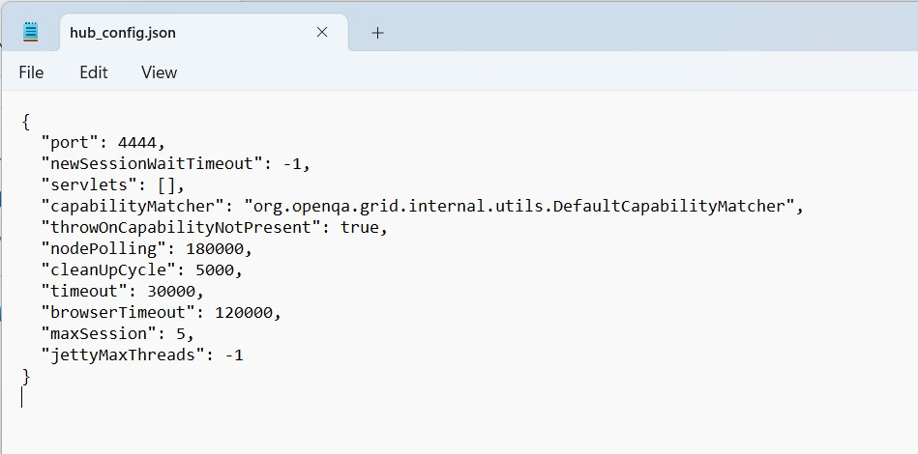

Java -jar selenium-server-standalone-3.141.59.jar -role hub -hubConfig Hub_config.json

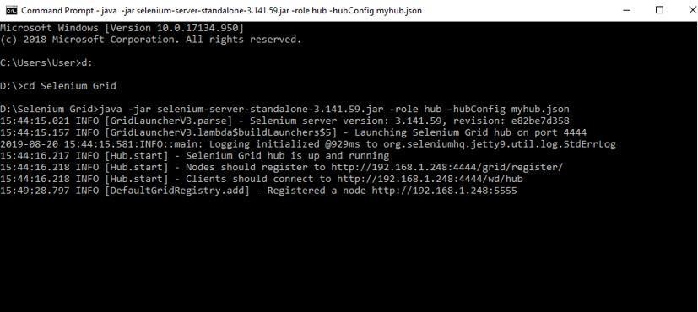

Mynodes.json

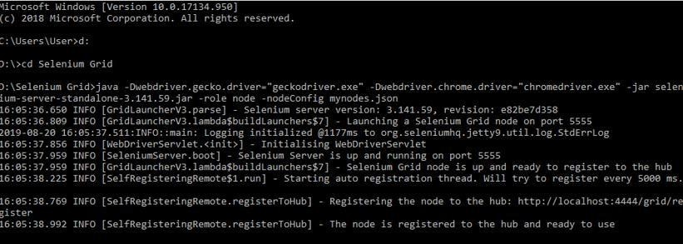

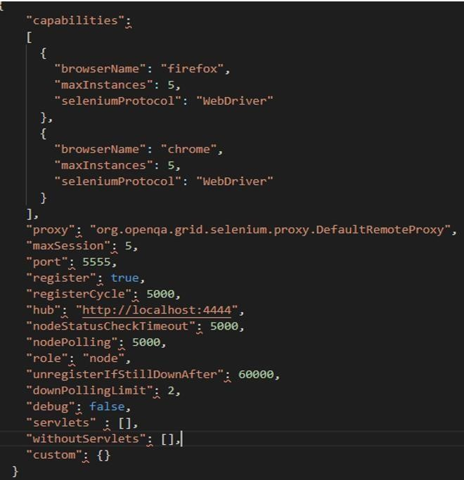

java -Dwebdriver.gecko.driver="geckodriver.exe" -

Dwebdriver.chrome.driver="chromedriver.exe" -jar selenium-server- standalone-3.141.59.jar -role node -nodeConfig mynodes.json http://localhost:4444/grid/console

